Bahrul ‘Ulum Fadhlur Rohman  
202110370311462  
Praktikum Mobile C

Latihan Modul 2

**Link Github**: <https://github.com/ulumfr/hotel-booking-app>

State Management

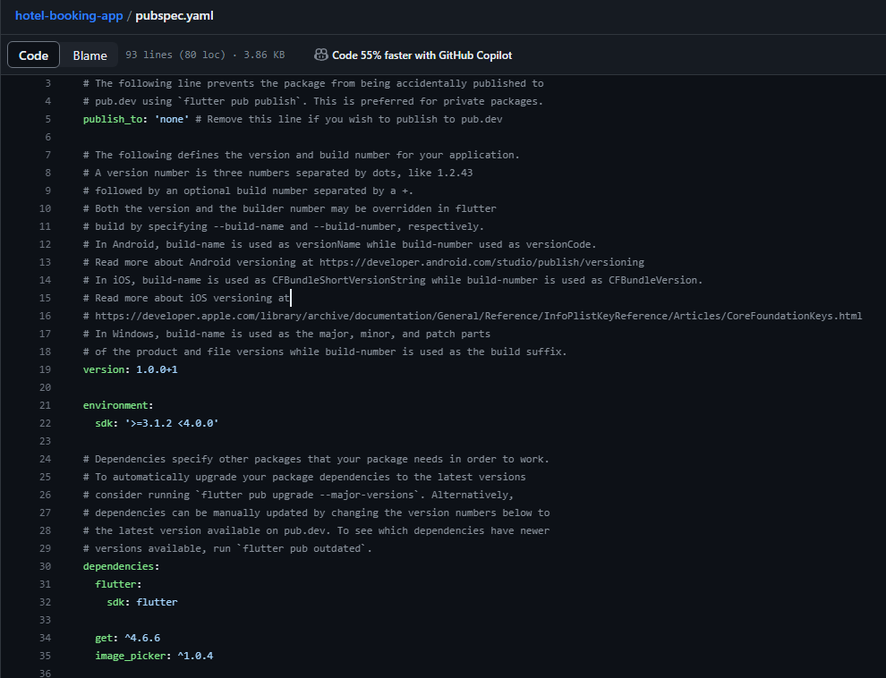

Refactoring Konsep MVC

1. Before

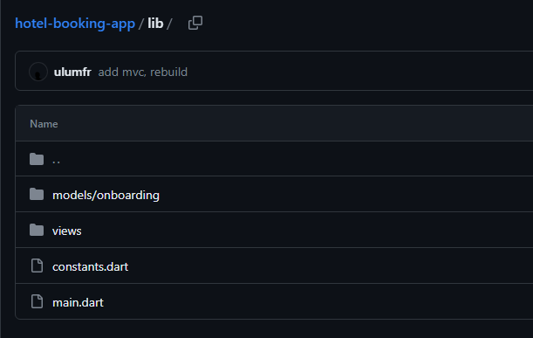

1. After

